|  |
| --- |
| Physics |
| Implementing machine-learning based accelerated Monte Carlo algorithm for 2-dimensional spin model |

Hyejin Kim 1

Dongkyu Kim 2

Dong-Hee Kim 3

1 Gwangju Institute of Science and Technology (GIST College), S. Korea, aadeliee@gm.gist.ac.kr

2 Department of Physics and Photon Science, Gwangju Institute of Science and Technology (GIST College), S. Korea, dkkim1005@gm.gist.ac.kr

3 Department of Physics and Photon Science, Gwangju Institute of Science and Technology (GIST College), S. Korea, dongheekim@gist.ac.kr

Abstract

In this report, I am going to discuss the Ising model simulation and its further expansion and application. By studying and designing Monte Carlo method on a simple Ising model, we can obtain a fundamental understanding of the thermodynamic phenomenon of the magnet. Physical quantities such as magnetization, magnetic susceptibility, energy, and specific heat are used to analyze the critical point of this simple Ising model. Moreover, autocorrelation time is calculated to measure the efficiency of the overall simulation. Between two different updating models, Wolff cluster update showed better performance than Metropolis update method.

Using the above background process, we can apply a self-learning Monte Carlo method to a sophisticated model. Sophisticated models can be simulated using only the local update method, which is highly inefficient due to its slow-down near the critical temperature. The basics of machine learning techniques are applied here to map a complex system to the simple Ising model, and this has made a nice global update to be available on the complex system. In this report, we have used Ising model with plaquette interaction to show the performance of our self-learning Monte Carlo method. The self-learning method has successfully mapped plaquette Hamiltonian to a simple Ising model and showed reduced autocorrelation between updated spin configurations. However, the research revealed that using higher-order Hamiltonian as an image of mapping does not ensure accuracy and efficiency. Overall, the usage of self-learning Monte Carlo method can give us an understanding of the unknown, complex system, and further, we can expand our work to other models.

1. INTRODUCTION
   1. Monte Carlo simulation on Ising model

For square lattice, spin-1/2, simple classical Ising model, the energy configuration of the state is given by Hamiltonian,

where means the nearest neighbor in lattice site, and =±1.

This model is the simplest model of a magnet. indicates the interaction between nearest neighbors. It is ferromagnetic for , and anti-ferromagnetic for . ( stands for external magnetic field, which I will set as ​0.) Ising model has a critical point (second-transition point), and I am going to invest some special thermal properties that locate critical point.

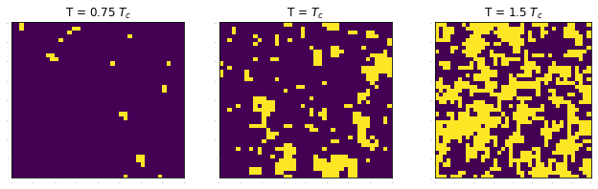

Figure 1. Spin configuration at different temperatures. (system size L=40)

There exist some exact solutions for 1 or 2-dimension lattice, however, I am going to examine this model on finite sizes using Monte Carlo simulation by C++ and python.

* 1. Self-Learning Monte Carlo method

​ For the classical Ising model, there exists a global update (e.g. cluster update) that reduces autocorrelation time successfully. However, for other sophisticated models, we can only apply a local update, and this update is extremely slow near a critical point. By the self-learning Monte Carlo method, we can figure out a faster global update for any model given by Hamiltonian. Furthermore, using self-learning method to analyze complex model will provide additional understandings from this complex model.

1. BACKGROUND

I will discuss some thermodynamic and statistical backgrounds as well as Monte Carlo methods. Also, I will briefly talk about some solutions for the Ising model in various dimensions.

* 1. Thermodynamics & Statistical physics
     1. Partition function

Partition function contains important information for a given system.

By using , we can drive some important physical quantities such as probability of states; . Knowing this function is about knowing everything in this system. (I will talk about it below section 2.1.2.) However, it is usually hard to get exact function when the system size increases, as it is impossible to sum all existing states. By conducting Monte Carlo method (section 2.3.1), we could obtain this function quite accurately.

* + 1. Free Energy

Helmholtz free energy of a system is given by ​ and other thermodynamic quantities can be obtained by simply calculation. As ​,

which implies .

Moreover, using these, we can obtain order parameters. Here, ,

where is internal energy, is specific heat capacity, is magnetization, and is magnetic susceptibility. So, by knowing the partition function, we could derive almost all quantities that we need.

* 1. Some solution of classical Ising model [2]
     1. Exact solution for 1-dimension Lattice

Consider 1-dimensional Ising model of periodic boundary that has ​ sites. Given Hamiltonian, the partition function is

The part acts like a matrix, as each spin is either 1 or -1.

This matrix has eigenvalue of

For B=0, . Using this, we can calculate free energy and internal energy each.

* + 1. Mean Field theory for d-dimension Lattice

From same Hamiltonian above, we will discover partition function using mean field theory. First, let ​, and put into Hamiltonian.

,

Large ​ will cause 2 stable point of ​ and 1 unstable point ​. For small ​, ​ is the stable point. The point of transition will be the transition point, which is ​ with dimension ​.

* 1. Markov Chain Monte Carlo

Above, I explained that the exact partition function is difficult to figure out, however, by statistical Monte Carlo simulations, solving these functions are available. Generally, we use a **Markov chain**. It requires careful design, as it must satisfy some properties.

* + 1. Markov Chain (MC) [6]

The first-order Markov chain only depends on the last previous state (conditional probability) and can be described by transition function.

This chain is homogeneous if ​. A distribution is invariant/stationary when a transition function of the chain leaves the distribution unchanged, i.e.

Designing a transition operator that makes distribution stationary is important in our case. The transition operator satisfies **detailed balance** by

If this detailed balance is satisfied, the distribution is stationary under .

Moreover, if the distribution ​ (invariant) when ​, then the chain has property **ergodicity**. A poorly designed operator might divide a set into certain states. That is, the distribution can reach any state after a long time from any state.

* + 1. Application: updating method

In general, the transition operator from to is given by .

* + - 1. Local update: Metropolis-Hasting algorithm

We want to obtain . First, initialize; , and proceed to next following steps.

1. Propose ​
2. Accept ​ with an acceptance ratio ​
3. If accepted, ​. Else, ​.
4. Repeat the above steps.

In our local update, a proposal is given by ​. I will briefly explain the scheme of this algorithm.

1. Define lattice size (​) and nearest-neighboring index. Initialize each spin site randomly or like chessboard, which has maximum energy level. (This will prevent super-cooling.) The nearest-neighboring index array will contain information of periodic boundary condition.
2. Define one Monte Carlo step (**1 MC-step**) as following:
   * Pick one spin site (randomly or checkerboard-style) and flip it.
   * Calculate the energy difference (​).
   * If energy difference less than 0, accept the spin-flip. Else, accept it by the probability of ​.
   * Perform the above steps for the whole spin site, which will be ​.
3. Calculate important thermodynamic quantities:
   * Before calculation, perform 2000~2500 MC-steps to obtain an accurate value.
   * Calculate magnetization and energy for 10000 times. For each data, throw a few steps according to the autocorrelation time. (e.g. Metropolis: ​, Cluster: ​) Without this throwing process, we will experience a certain bias of the observed value.
   * Calculate magnetization, magnetic susceptibility, energy, specific heat...etc.
4. Do the above steps for different temperature. Invest some quantities near the critical point.
   * + 1. Global update: Cluster update [5]

Above local updates such as Metropolis update takes tremendous time and large autocorrelation between each state. I will propose the most successful global update method, which is a cluster update. There are some fundamentals (**Fortuin-Kasteleyn cluster decomposition**) to discuss before explaining the algorithm.

First, let ​ and ​. Remove interaction between fixed nearest-neighboring site of ​ : .

Define new partition function, considering rather are same or different.

The original partition function is . Moreover, define ​, then partition function .

Since contains only when , and contains no restriction for spin-links, the weighing factors can be considered as probabilities of bond between site .

By using the above probability, one can create a cluster for a simple Ising model.

I will introduce **Wolff-cluster update**, which has proposal ​. (And has acceptance ratio ​.)

1. Choose a random site ​, and select nearest-neighbor ​.
2. If ​, bond to cluster with probability ​.
3. Repeat step 1 for site ​, if it was in the cluster. Keep until no more bond is created.
4. Flip the entire cluster.
5. Method

To analyze certain thermodynamic model, we need to calculate and obtain some thermodynamic quantities for each temperature. There are some interesting results in differing sizes of the system. I will introduce the mechanics of analyzing the Ising model. Furthermore, to conduct self-learning Monte Carlo simulation, I will also briefly introduce the scheme on this.

* 1. Ising model Analysis
     1. Finite size scaling: critical exponents [4]

Usually, a genuine value of critical point can only be obtained from an infinite system. For the finite-size system, the phase transition is smooth and inaccurate, which needs some additional interpretation. For each pseudo-critical temperature at a certain size, we can guess the accurate critical temperature.

We can find a singular point of free energy on temperature domain. This can be expressed as a function of size and temperature.

Calculation from free energy, we have nice scaling factors given by

Ising model's critical exponents are known as . Moreover, . Here, I am scaling using .

Plot ​ versus ​ to draw function ​, and find the maximum point ​. At this point, we can figure out real critical temperature by ​ (​: pseudo-critical point at size ​.) Plotting ​ versus ​ will predict the real critical temperature.

Additional quantity to measure is Binder cumulant . By examining higher order, we can invest ​ more precisely.

As system size goes to infinity, for and for . This quantity shows clear convergence near critical point.

* + 1. Error analysis: Jack knife [5]

As we calculate functions which has a dependency on the previous state (i.e. autocorrelation), normal calculation of error does not work. We must implement a new error-analyzing method for a given quantity ​.

1. Calculate average ​.
2. Divide data into ​ blocks (called binning); block size must be bigger than the autocorrelation time, to eliminate the impact of correlation.
3. For each block ​, calculate ​
4. Estimate error: ​

As this method slices data into several blocks, its name is Jack knife. In general, the error estimated from Jack knife method is larger than the normal error (standard deviation, usually.) Jack knife error generally times larger than the calculated error.

* + 1. Autocorrelation time [7]

The autocorrelation function is the correlation of some parameter with delayed-itself as a function of time.

For error analysis, we usually use **integrated autocorrelation time**.

By fast Fourier transformation (FFT), we can sum up the values in reduced time. Calculating the integrated autocorrelation time of the given parameter takes only ​ time.

* 1. Self-Learning update method [8]

The local update is the most general one, that can be performed on any model, but very slow and inefficient. On the contrary, the global update is the most preferred one due to its speed and efficiency but can only be applied on specific models. In this paper, the author developed some general global update method using self-learning, mainly by linear regression. The brief outline follows below.

1. Perform original local update using Metropolis-Hastings algorithm to make training dataset.
   * The data contains the energy of spin configuration (, nearest-neighbor correlation (, next-nearest-neighbor correlation (), and third-nearest-neighbor correlation (). I will also vary the size of dataset for training. (​)
2. Learn effective Hamiltonian from this data: Using linear regression on energy and spin-correlations.
   * Effective Hamiltonian ​: I will only consider case ​ and ​.
   * Linear regression: Using python NumPy library, ​ and ​ is calculated from given training data.
3. Propose a move according to effective Hamiltonian, i.e. **create a cluster** using ​.
   * Two different cluster-formation is elaborated below. (section 3.2.1 & 3.2.2)
4. Determine whether the proposed moves(=cluster) will be accepted(=flipped), using original Hamiltonian. The acceptance ratio is given by

However, the cycle is not over yet. We must obtain training data from a critical point, where the local update performs poorly. To prevent this situation, we use a series of linear regression.

* 1. Perform step 1 to get initial training data at temperature higher than critical point, such that ​, and perform step 2.
  2. By derived effective Hamiltonian, create next training data by doing step 3 and 4 at ​. Perform step 2 again.
  3. Repeat 'step B' until the temperature reaches point ​.

Lastly, by derived effective Hamiltonian, we will compare this with the original Hamiltonian. The comparison is conducted by calculating R square on given temperature range,

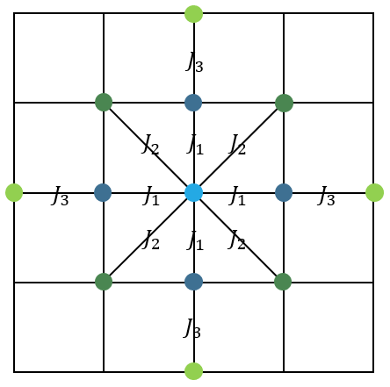

Figure 2. Diagram of (dark blue) 1st, (green) 2nd, and (light green) 3rd nearest neighboring spin.

To form a cluster considering only nearest-neighbor () is simple, which is just a Wolff cluster method. However, to consider higher order correlation such as next-nearest-neighbors () and third-nearest-neighbors () is a complex problem. I have considered two methods to solve this problem.

* + 1. Method A: Consideration of high-order spin correlation during cluster formation

The first method is by including and correlation directly during the construction of the cluster. The brief scheme of this algorithm is to search the correlation inside the cluster. This method goes like Wolff cluster, however, in the interval, it calculates higher order correlation.

1. Choose a random site ​. Select the nearest neighbor of ​, call it ​.
2. Search for 2nd-NN and 3rd-NN for ​, inside the cluster. The number of 2nd-NN and 3rd-NN inside the cluster is each denoted by ​. The probability to bond site ​ is ​.
3. Repeat step 1 for site ​, if it was in cluster. Keep until no more bond is created.
4. This cluster will be flipped by considering the acceptance ratio of above.

The key point of this cluster formation is the consideration of higher spin correlation inside bond-probability.

* + 1. Method B: Shift acceptance ratio of cluster flipping

The second method is to change the acceptance ratio. Form a cluster regarding only ​ correlation (=Wolff cluster method) and accept/reject this cluster flip by considering effective Hamiltonian, which contains ​ correlation. This method was inspired by the shift of acceptance ratio during self-learning.

1. Construct Wolff-cluster using only information about 1st-NN, as normal. This step is identical to Wolff-cluster formation.
2. Accept this cluster flip regarding given Hamiltonian, which includes 2nd and 3rd-nearest spin correlation.

Where ​ implies the effective energy calculated using only 1st-NN. This step is just like self-learning acceptance operator.

1. This cluster flip will again be either accepted or rejected regarding ​, which is the acceptance operator introduced above.

For the overall acceptance ratio of cluster,

where stands for original Hamiltonian that we are interested in, for effective Hamiltonian, and for effective Hamiltonian of 1st-NN.

To test whether these two methods are acceptable, I performed cluster-formation and compared it to Metropolis algorithm, using below Hamiltonian. (This is because Metropolis algorithm can be applied to any model.)

Below figure shows whether these two methods well matches with real value (Metropolis update.)

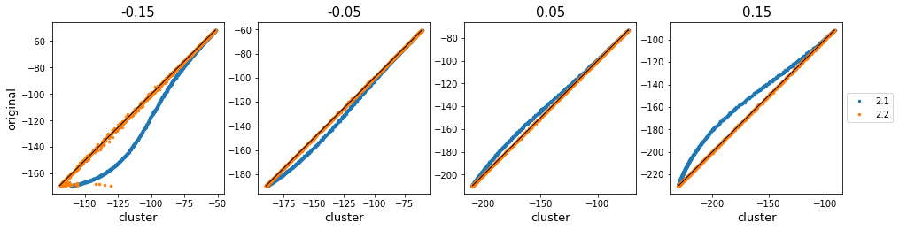

Figure 3. Comparison of accuracy of cluster update using method A/B

As ​ deviates from ​0, energy value obtained by method A diverges from the original value. This implies the detailed balance of this system has not been satisfied.

|  |  |  |  |  |
| --- | --- | --- | --- | --- |
| Method & | -0.15 | -0.05 | 0.05 | 0.15 |
| Method A | 0.84273832 | 0.99276231 | 0.99497835 | 0.95549145 |
| Method B | 0.99684442 | 0.99996033 | 0.99996566 | 0.99994447 |

Table 1. R square value comparison on energy

The above table shows the R​-value. In this next-nearest-model, the method B of changing the acceptance ratio works better. However, I will perform both methods on self-learning, and then compare these two.

1. Result & Discussion
   1. Classical Ising model

To begin with, the simplest classical Ising model is used in this section. The Hamiltonian is given by

First, a comparison between local/global update was conducted. For the next step, an examination of some important thermodynamic quantities of different sizes was conducted.

* + 1. Comparison of Local & Global update

A local update was performed using the Metropolis algorithm, and the global update was by the Wolff cluster algorithm. I have calculated the accuracy of the global update, and the efficiency of the global update compare to the local update.

* + - 1. R square

System size 16, 32, 48 was used to compare R square.

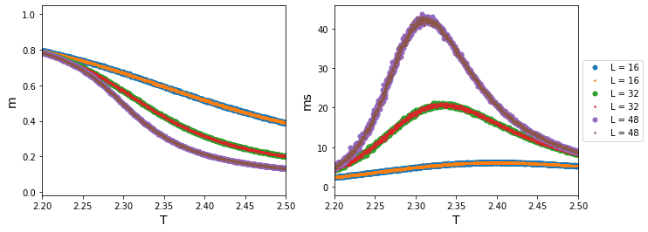 Figure 4. Magnetization and magnetic susceptibility on temperature domain. (big dot) Metropolis (small dot) cluster update.

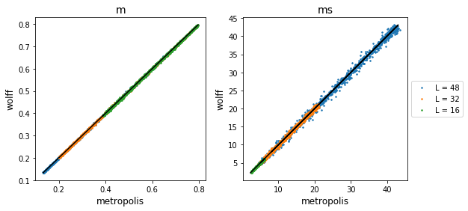

Figure 5. Accuracy of Wolff cluster method based on Metropolis. (left) Magnetization comparison (right) Magnetic susceptibility comparison

The above and below plot both show that two results obtained by Wolff cluster method and Metropolis method matches. We can conclude that the Wolff cluster algorithm works just as well as the Metropolis algorithm. We can conclude the Wolff method is also reliable.

* + - 1. Error comparison

Below figure shows the magnetic susceptibility plot with error bars using Jack knife.

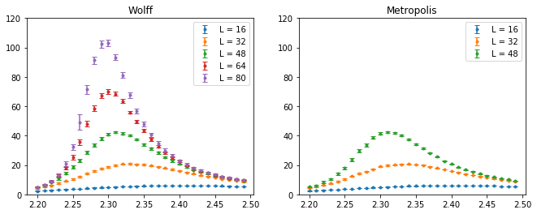

Figure 6. Magnetic susceptibility plots with error bars on temperature domain. (left) cluster method (right) Metropolis method.

Below, the orange dots are error calculated from the Metropolis, and blue ones are error from the clustering algorithm. There is a clear relation between autocorrelation time and the error obtained by jack knife; metropolis error was much bigger than cluster error, and error at the critical point was largest among given temperature range.

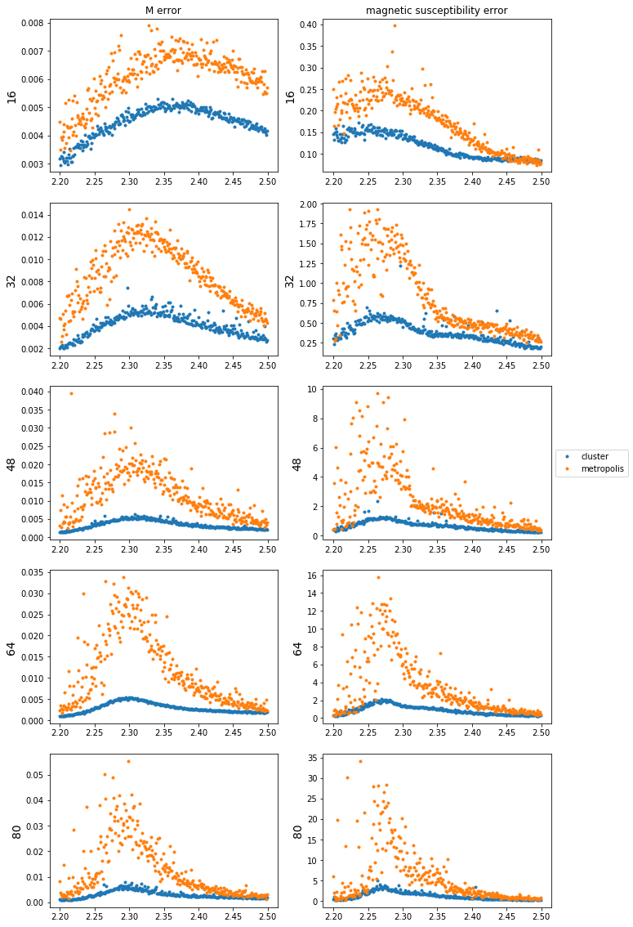

Figure 7. Plot of Jack-knife error on temperature domain. (left) Magnetization error (right) magnetic susceptibility error. (blue) Error calculation using cluster method (orange) Error calculation using Metropolis method.

* + - 1. Integrated Autocorrelation time

System size of 8, 16, 32, 64, 128 was used here to compare autocorrelation. Parameter such as magnetization and magnetic susceptibility was used to calculate integrated autocorrelation time for each algorithm. The calculation was on a critical point, which has the worst autocorrelation. We will start with magnetization autocorrelation time.

|  |  |
| --- | --- |
| Metropolis | Cluster |
|  |  |
|  |  |

Figure 8. (top) Autocorrelation function plot. (bottom) Integrated autocorrelation time. (left) Metropolis (right) Cluster

Below graphs shows ​. (​ for cluster, ​ for metropolis.) Moreover, I calculated the integrated autocorrelation time for magnetic susceptibility. ( for cluster, for metropolis.)

Cluster algorithm works much better than the Metropolis one. Autocorrelation time for Metropolis diverges faster than the clustering algorithm. At system size 128, it gets terribly inefficient. As the clustering algorithm has less autocorrelation time, we can throw fewer steps to obtain results that we need. For these reasons, I am going to use the Wolff cluster method for investing the Ising model's finite size effect.

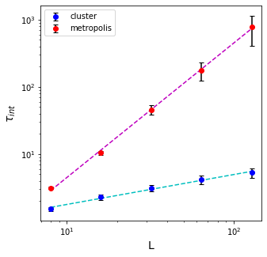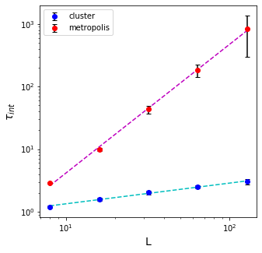

Figure 9. Comparison of integrated autocorrelation time on cluster and Metropolis update, by differing sizes. (left) Magnetization. (right) Magnetic susceptibility.

* + 1. Comparison of Lattice size

System size of 16, 32, 48, 64, 80 was used here to investigate finite-size effects. Here, results were received by conducting a cluster update.

* + - 1. Thermodynamic quantities

Overall, magnetization was used here to calculate some quantities, such as magnetic susceptibility and Binder cumulant of magnetization.

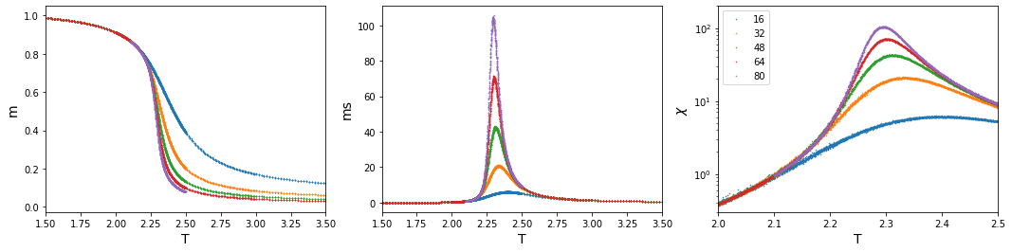

Figure 10. (left) Magnetization (center) Magnetic susceptibility (right) Magnetic susceptibility in log scale at temperature domain.

Obviously, as size increases, the more it acts as an infinite size. Magnetization drops exponentially at a critical point. Also does magnetic susceptibility. As the size grows, magnetic susceptibility diverges at a critical point. However, we can figure out some subtle critical-temperature shifts as varying system size. To accurately obtain a critical point, we must perform some other analysis.

* + - 1. Binder cumulant

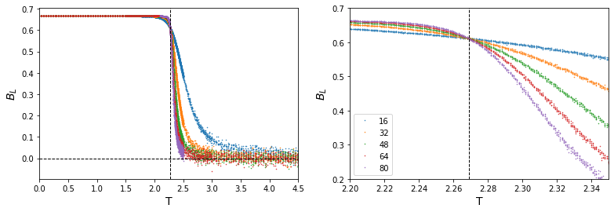

Figure 11. Binder cumulant by differing sizes, on temperature domain.

The vertical dashed line (--) represents the critical temperature, where . At critical point, we can see Binder value converges.

* + - 1. Finite size scaling

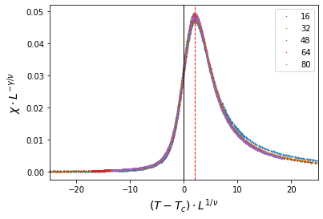

Figure 12. Finite size scaling with given critical exponents. The position of maximum y position is 1.968705. (read dashed line)

The above result shows that the well-known critical exponents of the Ising model match exactly with our model, which implies our simulation is successful. To obtain genuine critical temperature, we must do 'finite size scaling' from each pseudo-critical value.

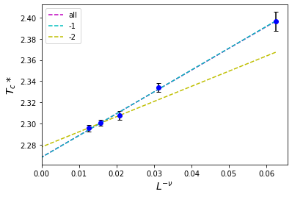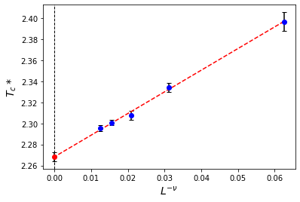

Figure 13. Finite size scaling domain. (left) linear fitting curve (right) linear fitting curve by considering errors.

The left plot shows the linear fitting curve. The y-intercept of these lines indicates the predicted critical temperature.

* include all points: ​ 2.053837x+2.268260
* exclude point L=16​: ​ 2.059052x+2.268162
* exclude point L=16, 32​: 1.430204x+2.277027

By considering some standard deviation and errors, we could conclude that the critical temperature is around . Our result deviates only 0.0012 from well-known value.

* 1. Self-Learning Monte Carlo method

I will mainly perform self-learning on plaquette-Ising model, which is

I will focus on the case where ​. (Both positive and ferromagnetic.)

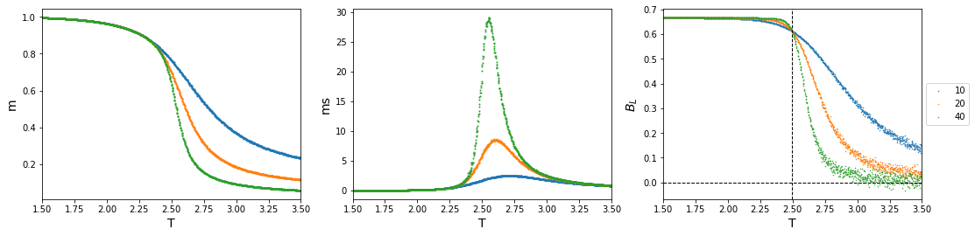

Figure 14. Thermodynamic quantities from plaquette-Ising model. (left) Magnetization (center) Magnetic susceptibility (right) Binder cumulant.

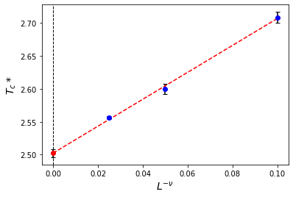

Figure 15. Finite size scaling of plaquette-Ising model.

By performing Metropolis-Hastings algorithm on a plaquette-Ising model of system size 10, 20, and 40, we assume that ​, however, I am going to use ​ as introduced in this paper.

First, I have performed Metropolis algorithm for fitting plaquette Hamiltonian (I'll call this *original Hamiltonian*) into effective Hamiltonian ​, differing the size of training data ​~​.

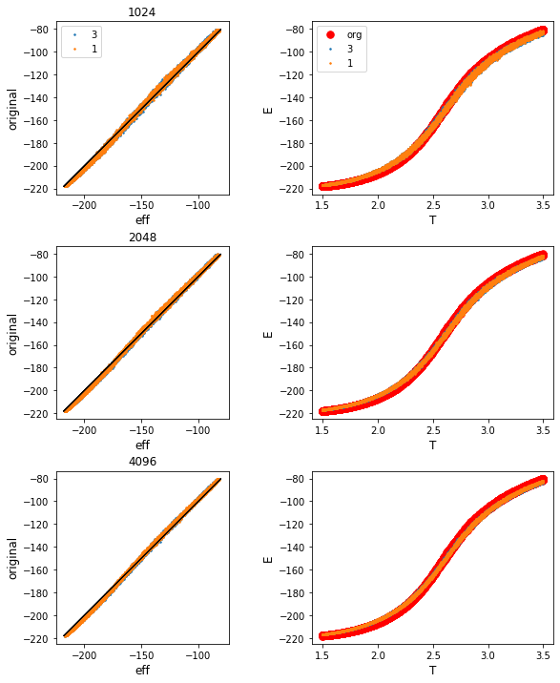

Figure 16. Comparison of effective Hamiltonian and original plaquette Hamiltonian.

|  |  |  |  |
| --- | --- | --- | --- |
| & train size | 1024 | 2048 | 4096 |
|  | 0.99776221 | 0.99793675 | 0.99804020 |
|  | 0.99769636 | 0.99795439 | 0.99800237 |

Table 2. R square comparison of effective Hamiltonian of 1st order and 3rd order.

Obviously, using larger training data size ensures high accuracy of the effective Hamiltonian. Indeed, considering 3rd-order correlation during fitting (i.e. fitting to 3rd order​) does not seem to have big difference with the ​ consideration. Considering only ​ in this case will work well.

* + 1. Compare two cluster-formation methods
       1. Method A: Consideration of high-order spin correlation during cluster formation

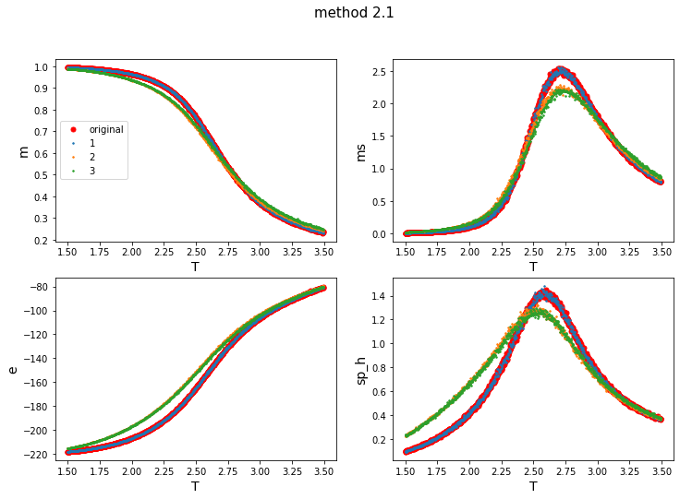

Figure 17. Comparison on thermodynamic quantities: original Hamiltonian vs. effective Hamiltonian using 1st, 2nd, 3rd order, with method A.

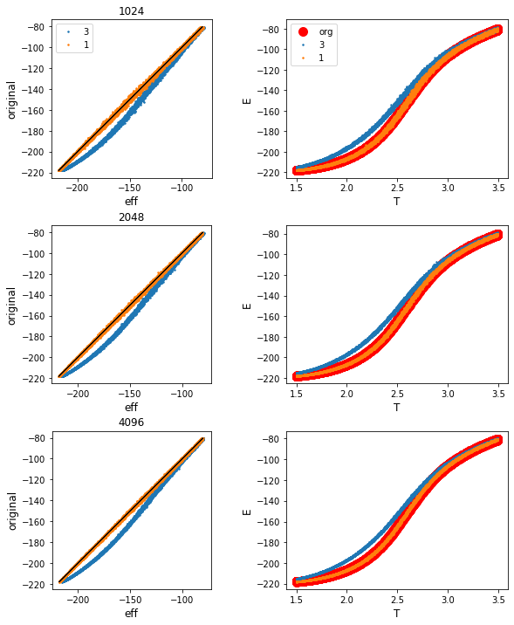

Figure 18. Comparison on energy configuration: original Hamiltonian vs. effective Hamiltonian of 1st, 2nd, 3rd order, with method A.

|  |  |  |  |
| --- | --- | --- | --- |
| R square & train size | 1024 | 2048 | 4096 |
|  | 0.99962688 | 0.99979280 | 0.99987757 |
|  | 0.96658696 | 0.96913168 | 0.97120511 |

Table 3. R square in each case: (top) 1st order effective Hamiltonian (bottom) 3rd order effective Hamiltonian.

|  |  |  |  |
| --- | --- | --- | --- |
| & correlation |  |  |  |
|  | 1.1120.001 | 0 | 0 |
|  | 1.2210.003 | -0.0680.004 | -0.0170.004 |

Table 4. List of correlation constant on effective Hamiltonian.

Considering 2nd and 3rd order spin correlation while forming a cluster does not seem to ensure an accurate result. It shows some deviation from the original-metropolis method. This cluster formation method in inappropriate in this case.

* + - 1. Method B: Shift acceptance ratio of cluster flipping

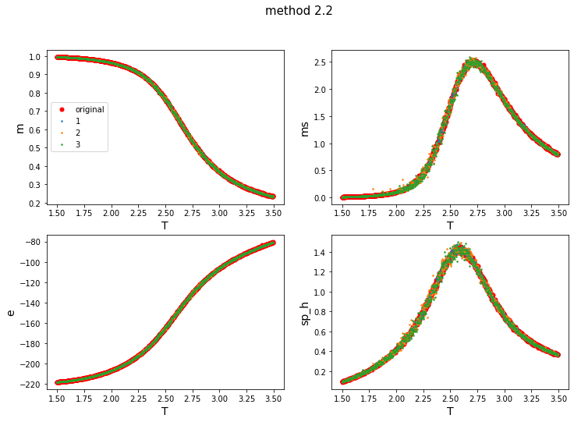

Figure 19. Comparison on thermodynamic quantities: original Hamiltonian vs. effective Hamiltonian using 1st, 2nd, 3rd order, with method B.

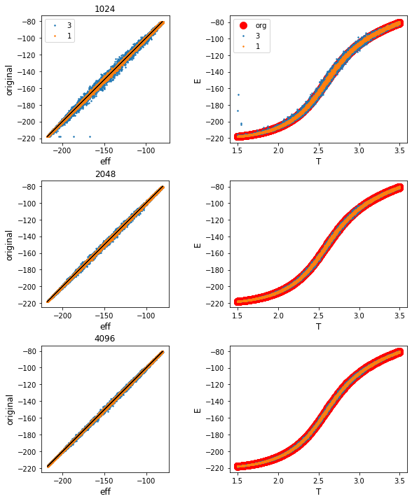

Figure 20. Comparison on energy configuration: original Hamiltonian vs. effective Hamiltonian of 1st, 2nd, 3rd order, with method B.

|  |  |  |  |
| --- | --- | --- | --- |
| R square & train size | 1024 | 2048 | 4096 |
|  | 0.99964976 | 0.99979158 | 0.99987428 |
|  | 0.99805295 | 0.99943005 | 0.99960797 |

Table 5. R square in each case: (top) 1st order effective Hamiltonian (bottom) 3rd order effective Hamiltonian.

|  |  |  |  |
| --- | --- | --- | --- |
| & correlation |  |  |  |
|  | 1.11260.0006 | 0 | 0 |
|  | 1.260.01 | -0.0990.009 | -0.0090.003 |

Table 6. List of correlation constant on effective Hamiltonian.

Cluster formation using method Bis more accurate and also works well during fitting ​3rd order spin correlation, compare to method A. Overall, implementing method B into self-learning performs much better, so I am going to choose this method for the next following analysis.

* + 1. Analysis of this model

To understand the self-learning exactly, we must know how it operates exactly, and understand the overall situation. First, I will calculate the actual acceptance rate of each model; two cases (1st, 3rd order) of effective Hamiltonian. Next, I will measure the integrated autocorrelation time for each case and compare it with the original-plaquette Hamiltonian. (Metropolis method) I will use method B for cluster formation.

* + - 1. Examine acceptance rate

Knowing the acceptance rate of a model is important since rejection-dominant model will not work efficiently.

To compare the overall acceptance rate, I performed cluster formation by different sizes and different steps at the critical temperature. A cluster was created based on the obtained values of , which was from self-learning linear regression.

Below, I had compared the acceptance rate for two types of effective Hamiltonian, in various system size. (Consideration of only ​ versus consideration up to ​.) The leftmost plot shows the acceptance ratio of level 1, which is the '​-cluster flip based on effective Hamiltonian'. The center plot shows the acceptance ratio of level 2, which is the 'effective-cluster flip based on the original Hamiltonian'. The rightmost plot shows the overall acceptance ratio.

Level-1 acceptance ratio is related to the similarity of the energy level of ​ cluster and the effective Hamiltonian. (Actual flip happens here.) Level-2 acceptance ratio is related to 'how much the fitting was successful.' The closer the effective Hamiltonian with original Hamiltonian, the more it will become accepted. The overall acceptance ratio explains how successful our cluster formation was.

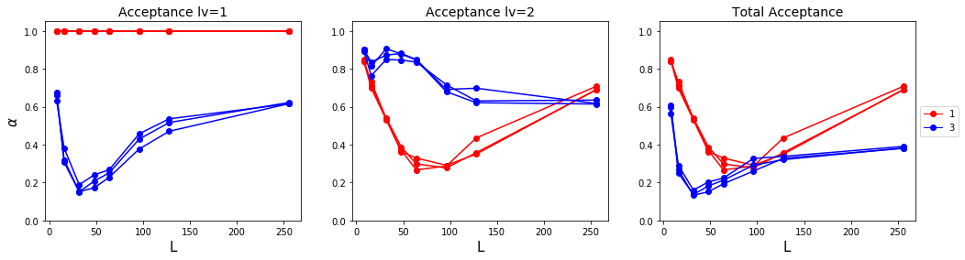

Figure 21. Acceptance level comparison on 1st and 3rd-order effective Hamiltonian.

Surprisingly, level-1 acceptance ratio dropped and elevated steadily for 3rd​ case. Moreover, for level-2 acceptance ratio, 1st​ case also showed some unexpected increase. (There was no surprise on level-2 acceptance ratio of ​3rd case.) Overall, both cases showed some unique patterns of acceptance ratio.

We could carefully suggest that this is related to the cluster's size. For small-sized systems, cluster size is also quite small, which makes it more likely to be accepted by original Hamiltonian. For a slightly larger system, it does not work well since the cluster size also gets big enough to be rejected. However, as the system gets large enough, the cluster size does not seem to affect this acceptance rate. We might guess that cluster size is bounded anyway.

Another analysis is solely about level-2 acceptance rate. Clearly, at a smaller size, -effective Hamiltonian is more likely to be accepted than the effective Hamiltonian. We could simply claim that fitting is more accurate than fitting when the system size is small. However, as the system gets larger, there was a reverse; effective Hamiltonian seems to work well. The total acceptance rate shows that fitting will work well during self-learning.

Overall, there seem to have some bounded limit for acceptance rate. We can expect that large-size system’s autocorrelation time will be less than our expectation.

* + - 1. Efficiency: Autocorrelation time

The paper demonstrates that the self-learning method is useful due to its efficiency and reduction in autocorrelation time. To check this fact, I calculated integrated autocorrelation time for various sizes; 8, 12, 16, 24, 32. There are two cases to compare: one is -effective Hamiltonian, and the other is -effective Hamiltonian. I would compare this result with the original Hamiltonian, which was performed using Metropolis algorithm. The calculation was held at the critical point.

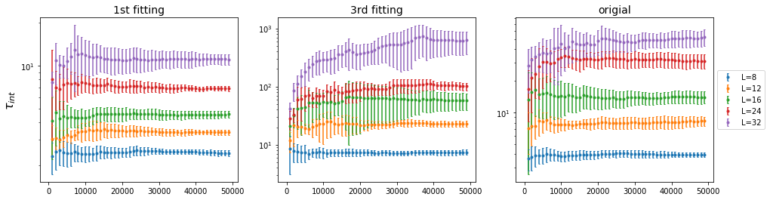

Figure 22. Integrated autocorrelation comparison on each case. (left) 1st effective Hamiltonian (center) 3rd effective Hamiltonian (right) original plaquette Hamiltonian.

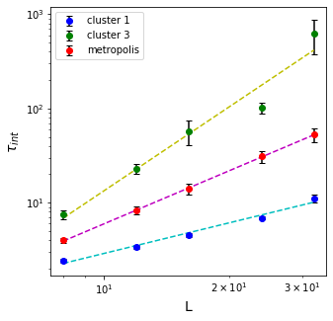

Figure 23. Logarithmic scale on integrated autocorrelation time on size-domain.

For 1st-order effective Hamiltonian fitting, the exponent value(=slope) is ​. For 3rd-order effective Hamiltonian fitting, the exponent ​. Compare to original metropolis exponent ​, ​ fitting has larger autocorrelation time. We can assume that due to its low acceptance rate, cluster formation was not fully reflected, which leads to huge autocorrelation between each step of Markov chain. However, the ​-fitting showed great reduction on autocorrelation time. We can conclude that self-learning simulation on plaquette-Ising model is successful.

It was surprising that original metropolis exponent did not reach value 2​. I have only conducted this calculation on small-size systems (​). This may cause major error in estimation of autocorrelation time.

1. Conclusion

By conducting Monte Carlo method on the Ising model, we could receive a fundamental understanding of the thermodynamics phenomenon on the magnet. Thermodynamic quantities such as magnetization and magnetic susceptibility revealed the critical point of this model, by finite-size-scaling. Moreover, we could understand the basic rules of many-body interaction, and how we must design a Markov chain. Simulating this simple magnet model gave us some perception of the overall Monte Carlo method. Based on this method, two different update method was proposed. The efficiency of these two methods-local and global update-were calculated. Global update such as Wolff clustering method works much better than basic Metropolis update. Knowing this overall mechanism, we can now apply these methods to various situations.

To apply a similar Monte Carlo method to a more sophisticated model, we have proposed a self-learning method. Self-learning Monte Carlo method was successful during the whole research. By using the basics of machine learning techniques, we have mapped the complex system to the simplest Ising model, which has well performing global update. This mapping made us available to apply a nice global update on this sophisticated model system. In this report, Ising model with plaquette interaction was used to evaluate the performance of self-learning method. By using a two-level acceptance operator, we could successfully reconstruct this complex system into a simple, well-known Ising model. This self-learning Monte Carlo method has increased efficiency by reducing autocorrelation and prevented critical slow-down during the performance of this complex system. However, using high-order effective Hamiltonian does not ensure accuracy and efficiency. This phenomenon might involve the size of the cluster during the global update. In the middle-sized system, the acceptance rate diminishes, which causes large autocorrelation and slow-down. This phenomenon usually occurs at high-order fitting. We could conclude that self-learning on the 1st-order spin correlation is appropriate in this case. By using the self-learning Monte Carlo method, we can further expand our work to other models and compare their performances.

Some issues need to be improved in this research. For the Ising model, simulation code optimization is not fully done yet. Due to its time inefficiency, I could not perform this simulation on a larger size system. I only perform Monte Carlo method on system size up to 80, this will cause some minor errors for finite-size scaling. As I soon optimize the Monte Carlo code, I can obtain the more exact value of the critical point.

On top of that, there are a few suggestions to improve this research regarding self-learning Monte Carlo simulation. First, due to a huge time-cost on calculating autocorrelation time, I had not much time to calculate it on the larger-sized system. However, based on the calculation of acceptance ratio on the larger size, we might suggest that integrated autocorrelation time will increase slowly at a large size. Without time constraints, I would conduct study on larger systems to obtain more accurate autocorrelation exponents. Moreover, I have not yet implemented a restricted-Wolff cluster update which was elaborated in the paper [8]. According to this paper, we can increase the acceptance rate by restricting the size of the cluster. By implementing this method, we can expect to reduce autocorrelation on case with high-order spin correlation fitting. Furthermore, I have not tried to simulate self-learning method on other models such as frustration. Also not tried to change plaquette interaction constant. We can probably guess that as plaquette interaction gets dominant, then self-learning method will not work well as before.

Further study will improve both the accuracy and efficiency of the overall self-learning Monte Carlo method. By this simulation, we can broaden our understanding of many unknown sophisticated models, beyond the classical Ising model.

1. REFERENCES

[1] M. E. J. Newman and G. T. Barkema, *Monte Carlo methods in statistical physics*. Oxford: Clarendon Press, 2001.

[2] L. E. Reichl, *A modern course in statistical physics*. Weinheim: Wiley-VCH, 2017.

[3] C. J. Adkins, *An introduction to thermal physics*. Cambridge: Cambridge University Press, 2004.

[4] D. P. Landau and K. Binder, *A guide to Monte Carlo simulations in statistical physics*. Cambridge, United Kingdom: Cambridge University Press, 2015.

[5] K. Rummukainen, in *Monte Carlo simulation methods*, 2019.

[6] F. Wood, “Markov Chain Monte Carlo (MCMC),” in *C19 MACHINE LEARNING - UNSUPERVISED*, Jan-2015.

[7] D. Foreman-Mackey, “Autocorrelation time estimation,” *Dan Foreman-Mackey*, 17-Oct-2017. [Online]. Available: https://dfm.io/posts/autocorr/. [Accessed: 20-Aug-2020].

[8] J. Liu, Y. Qi, Z. Y. Meng, and L. Fu, “Self-learning Monte Carlo method,” *Physical Review B*, vol. 95, no. 4, 2017.